**Week 6**

**1.ReactJS – HOL**

**FILE STRUCTURE**

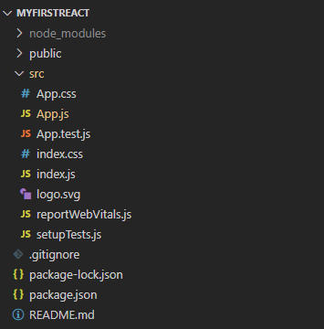

**CODE**

*C:\Users\User\Desktop\myfirstreact\src\App.js*

import logo from './logo.svg';

import './App.css';

function App() {

  return (

    <h1> Welcome the first session of React </h1>

  );

}

export default App;

**OUTPUT**

